Nama : Farkhan Mauriza

NIM : 18090103

Kelas : 5D

Laporan Praktikum 5

1. Source Code

MatakuliahValidation.php -> application/controllers/

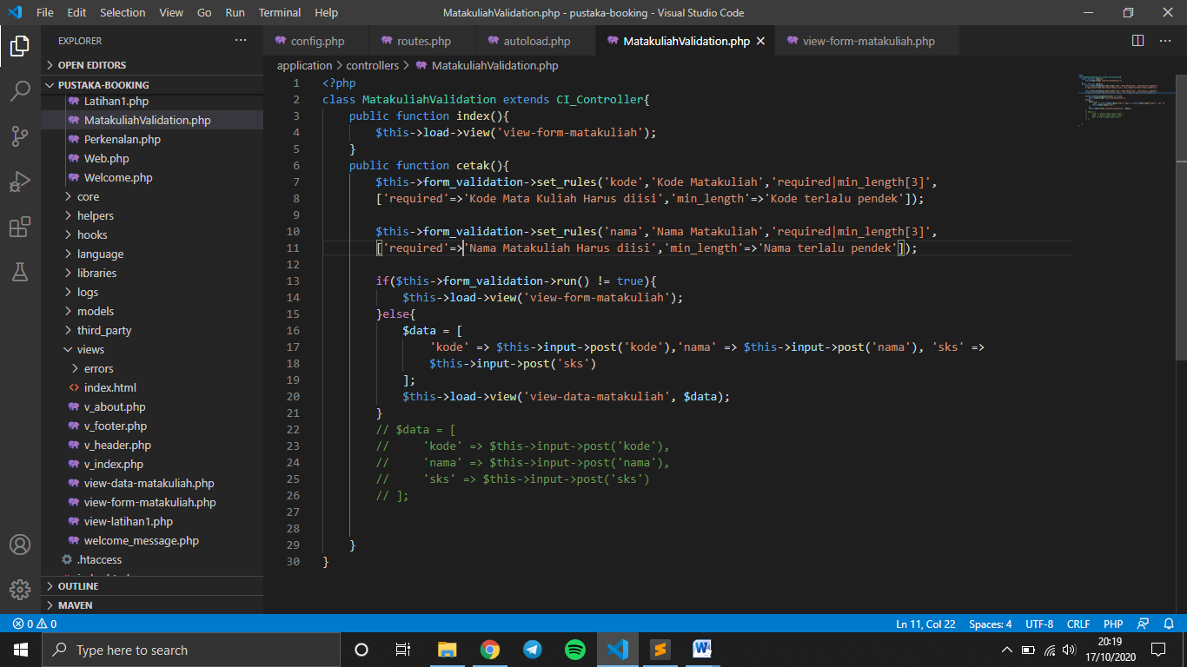

autoload.php -> application/config/

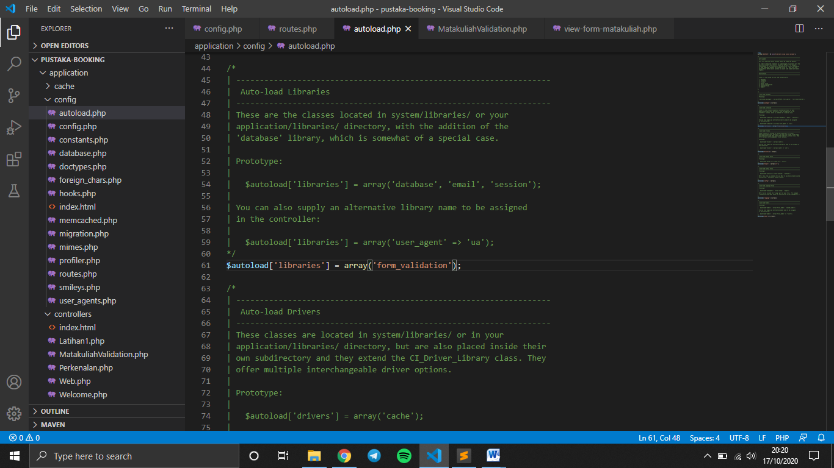

view-form-matakuliah.php -> application/views/

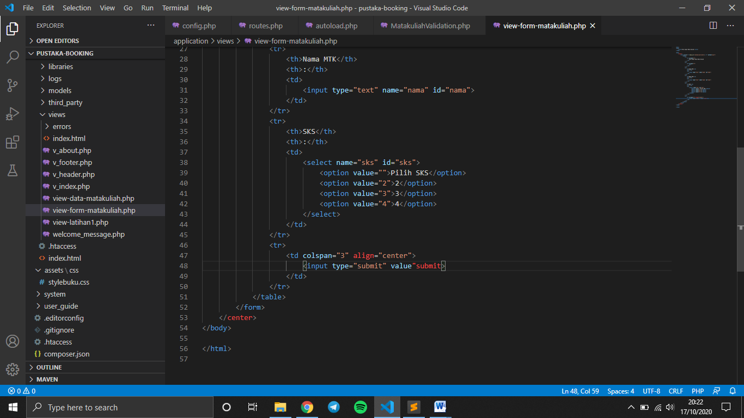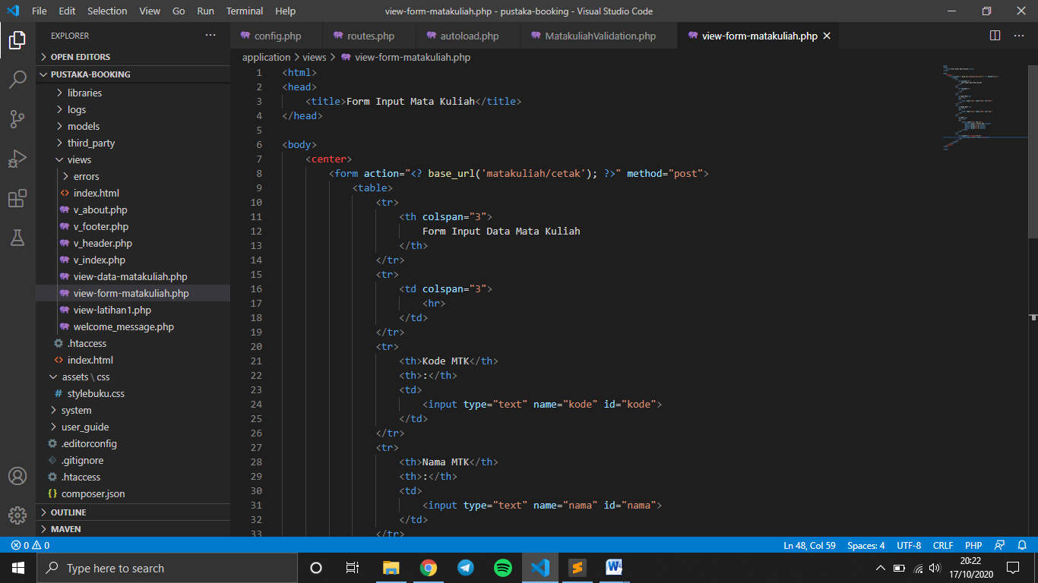

1. URL

http://localhost/pustaka-booking/MatakuliahValidation

1. Capture Output Program

